CQS User Manual



Running the CQS App 4

The Main Application 4

Load Data 6

Load into a New Table: 6

Load into an Existing Table: 6

Common errors 7

Raw Data Display 7

Filtering Columns 8

Add a crash entity 8

View this Entry 8

Delete a crash 9

Edit a crash 10

Entering Crash Details 11

Submitting the Crash Entry 11

Common errors 11

Simple CAS Data Viewer 12

Filtering Columns 12

Common errors 12

Query 13

How to Query? 13

Select Attribute 13

Select Operator 14

Common Mistake 14

Enter Statement 14

Query Examples 14

Filter Columns 15

Activating column filters 15

Common errors 16

Map View 16

Detailed Pin Information 16

Graph View 17

Generating a Graph 17

Updating an Existing Graph with different dataset 17

Common errors 18

Pagination 18

Navigating Pages 18

Using singe arrows 18

Using page numbers 18

Direct Page Entry 18

Using Double Arrows: 19

Common errors 19

Delete Table 19

Deleting a table 19

Additional information 19

# Running the CQS App

# The Main Application

In this section we will outline features which will be present throughout the use of the application. Each of these features are situated on the left-hand navigation panel which is shown close-up in **Figure 1.**

The features have been split into three. ‘Select Dataset’ which allows you to toggle between loaded in data sets, ‘App Views’ which swap out the way you are viewing the crash data, and ‘Data Options’ which when clicked create popups (modals) which have very specific functionality.

Figure 1: The navigation panel

*Select Dataset Dropdown:* *This can be used to switch the dataset you wish to populate the current window with.*

*If you wish to delete one of your datasets, simply right click on the table you want to delete. You will be met by a warning message as this cannot be reversed!*

*Detailed table deletion information* *here*

*Refresh button*: *This can be used to clear the currently applied query. Fully resetting the current display. Warning: You will not be able to re-retrieve your query!*

*This button redirects you to* *Graphing View**:*

*This is where you can generate your own graph based on filters and queries.*

*This button redirects you to* *Mapping View**:*

*This is where you can generate your own graph based on filters and queries.*

*This button redirects you to* *Raw Data View**:*

*This is where you can see all 68 columns of each crash entry in a table view.*

*This button redirects you to* *CAS Table View**:*

*This is where you can see a simplified cohesive version of the CAS crash data*

*This button redirects you to* *Query* *Pop-up**:*

*This is where you can filter your data to meet certain criteria based on all attributes of a crash.*

*This button redirects you to the* *Load Table* *Pop-up:*

*This modal will allow you to create your own datasets, or add to an existing one. By loading a CSV, which is in CAS format.*

*This button will lead you right back to this PDF!*

*Use this to Exit the application.*

# Load Data

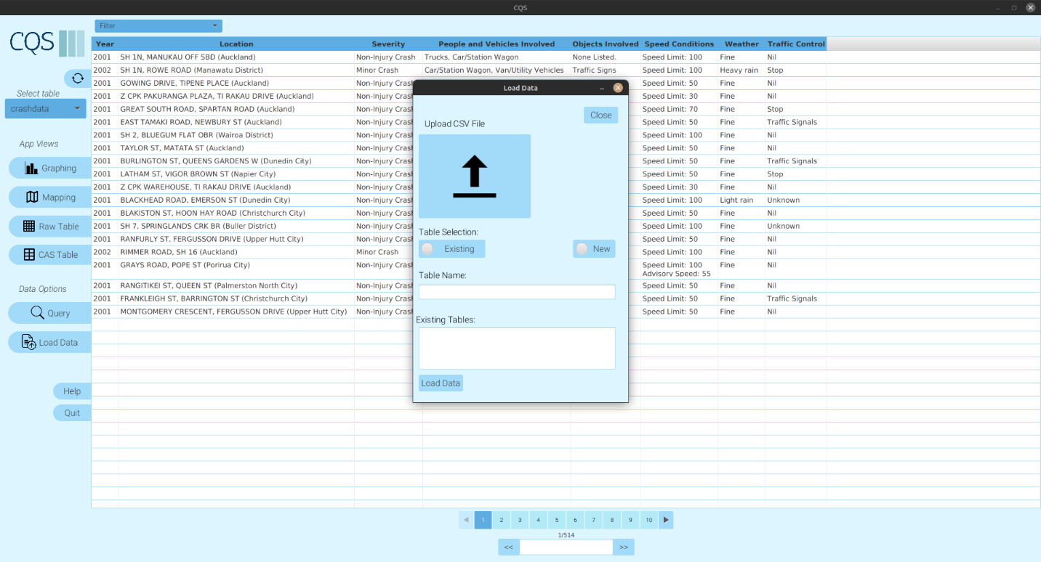

Figure 2: The load-data popup displayed over the main window.

## Load into a New Table:

Open the "Load Data" modal window.

Choose your desired CSV file from your local machine.

Ensure your table selection is set to "new".

Enter a unique and valid name for the new table.

Click the "Load" button.

A confirmation alert will appear, confirming that your data has been successfully loaded.

The "Load Data" modal window will close.

## Load into an Existing Table:

Open the "Load Data" modal window.

Choose your desired CSV file from your local machine.

Change your table selection to "existing".

Select one of the available existing table names.

Click the "Load" button.

A confirmation alert will appear, indicating that your data has been added to the existing table.

The "Load Data" modal window will close.

### Common errors

#### a. Incorrectly Formatted CSV File:

If you select an incorrectly formatted CSV file, upon trying to load data, an error alert will appear notifying that the CSV file is improperly formatted. The "Load Data" modal window will remain open for correction.

#### b. New Table with Existing Name:

If you try to create a new table with a name that already exists in the database, upon data loading, an error alert will inform that the table name already exists. The modal remains open for you to rename or take necessary actions.

#### c. Loading without Selecting Table:

If you try to load data without selecting a table (neither new nor existing), an error alert will appear prompting you to select an appropriate table option. The modal remains open for correction.

#### d. Load without Uploading File:

If you attempt to load data without selecting a CSV file, an error alert will notify you to choose a valid CSV file. The "Load Data" modal remains open for correction.

# Raw Data Display

Shown by **figure 3** is the raw data display. This shows all attributes of a crash entry.

To navigate, scroll horizontally to view various attributes. You may also select different pages via the page selector at the bottom. To skip to a specific page click into the text box and enter a number between 1 and the specified max page.

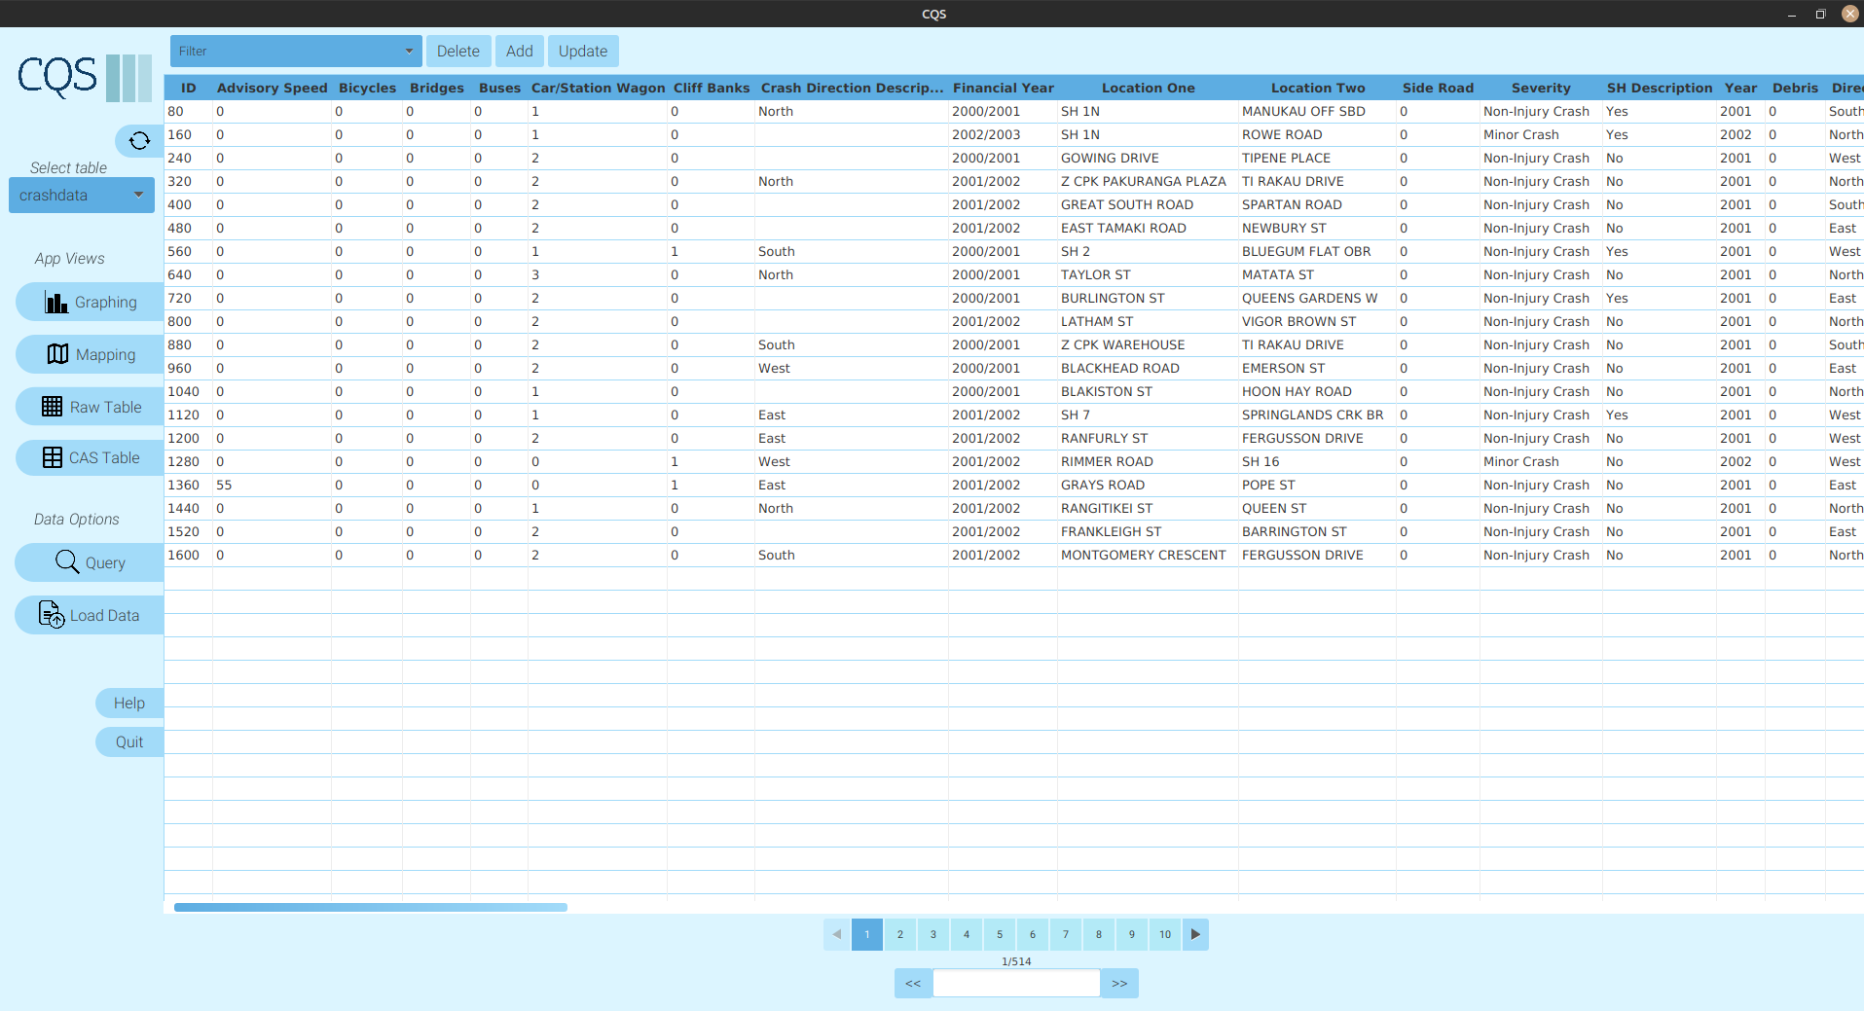

Figure 3: The Raw data viewer.

## Filtering Columns

Click on the "Filter" option to display a dropdown menu.

From this menu, you can select which columns you want to be visible. Uncheck columns that you wish to hide.

## Add a crash entity

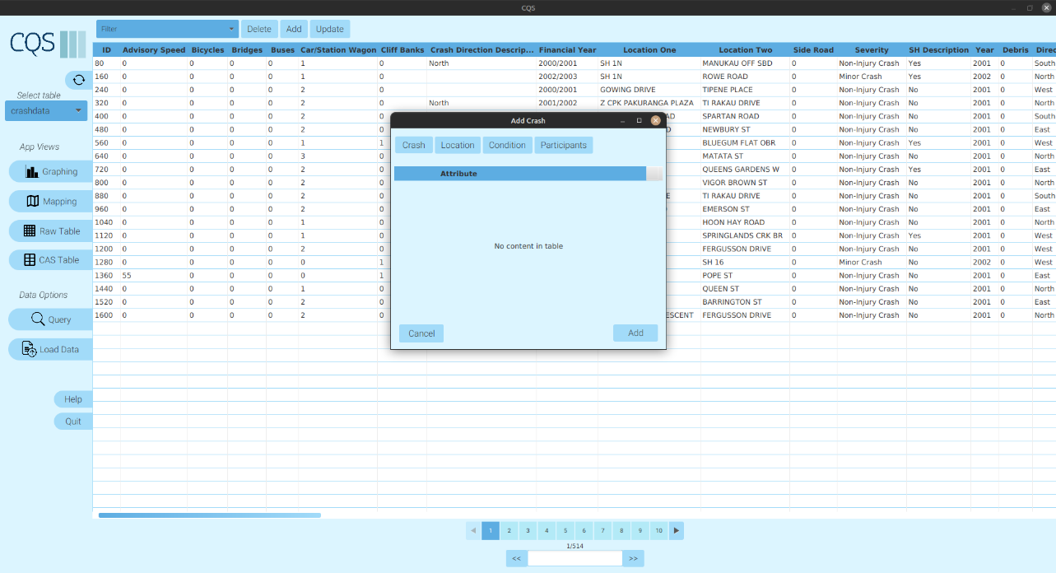

Figure 4: The Raw Data Viewer with the add data button highlighted

Locate and select the 'Add' button on the application interface. Clearly shown by **figure 4.**

See below to see how to add crash details.

### View this Entry

Look for the new entry in the dataset. This can be identified by a special ‘*’ marker next to the row (only in the raw data viewer). Hint: It is likely to be at the bottom of the table view.

## Delete a crash

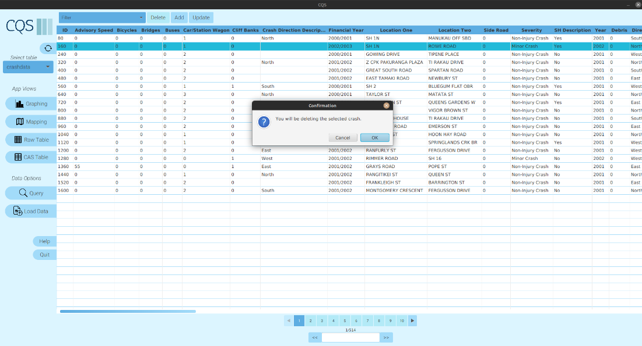

Figure 5: Raw dat viewer showing the delete button and the warning the user meets

Browse through the Raw Data Viewer to locate the crash entry you intend to delete.

Click on the respective row of the crash entry to highlight it.

Once the desired crash entry is selected, locate and click on the ‘Delete button’ typically found at the top or beside the entry.

A pop-up window will appear, asking for confirmation: “You will be deleting the selected crash. Are you sure?”.

You will have two options to proceed:

a. Confirm Deletion:

- Click on the OK or Yes button in the pop-up.

- The crash entry will be permanently removed from the database, and the Raw Data Viewer will automatically update to reflect this change.

b. Cancel Deletion:

- If you decide not to proceed with the deletion, click on the Cancel or No button in the pop-up.

- The Raw Data Viewer remains unchanged, and no data will be deleted.

## Edit a crash

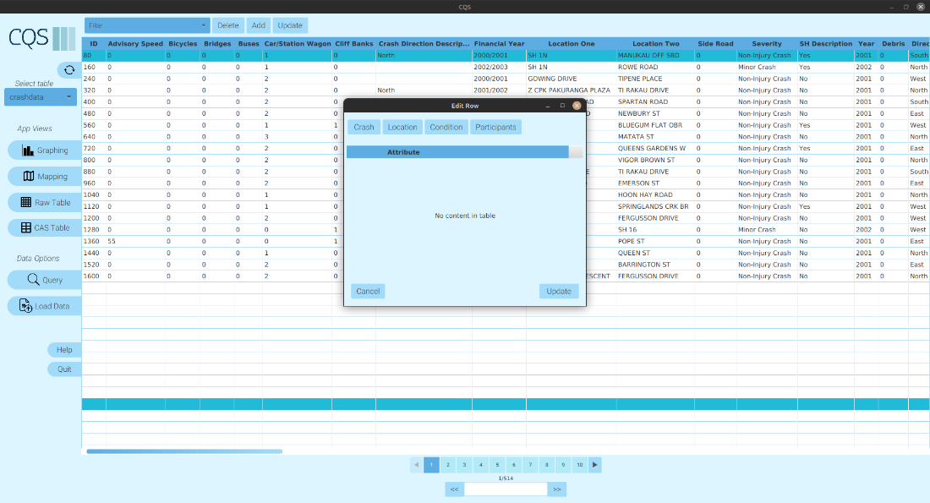

Figure 6: Snippet of the raw data viewer showing the update entry pop-up and the edit button

Double-click on the desired crash data entry you wish to update.

OR

Select the row of the crash data entry and then click the Update button, shown by a red circle on **figure 6**.

From here you may enter crash details. Tips on how to do this can be shown below in Entering Crash Details.

## Entering Crash Details

Figure 7: The different views of the update/add data modal

Populate the fields presented with the respective crash details. Make sure to fill in all existing attribute headers.

### Submitting the Crash Entry

Once all the details have been entered, click on the 'Add' button again.

A prompt will appear confirming the successful addition of your crash entry.

### Common errors

#### a. Using an already existing crashID:

If you attempt to enter a crashID that already exists:

An error message will appear suggesting: “This crashID is already in use.”. Enter a different crashID not entered in the DB.

#### b. Incorrect Data Type:

If you enter data in the wrong format:

An error message will pop up, highlighting the specific fields where the incorrect data type has been entered. For example, entering a number in a field that requires text.

#### c. Editing Without Saving:

Follow the same steps as mentioned editing the entry.

If you decide not to save the changes, simply close the edit modal window.

# Simple CAS Data Viewer

Upon entering the app, you will be presented with all relevant category strings and attributes associated with a crash. You can free roam and view all the raw data without any restrictions. This view is shown in **figure 4.** To navigate through the app you may scroll vertically and click on different pages displayed at the bottom of the screen.

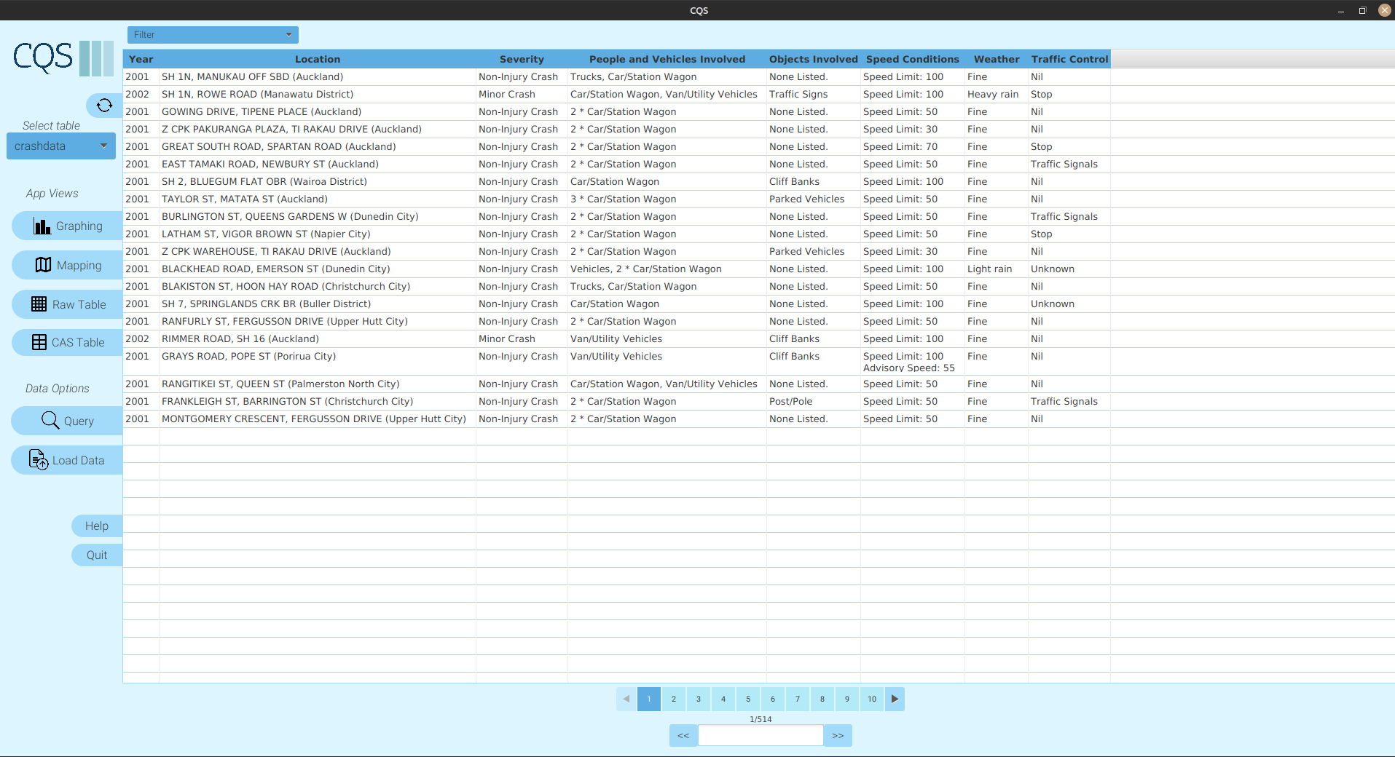

Figure 8: The CAS Data viewer

### Filtering Columns

Click on the "Filter" option to display a dropdown menu.

From this menu, you can select which columns you want to be visible. Uncheck columns that you wish to hide.

### Common errors

#### a. Hiding All Columns

If you decide to hide all columns, you will be redirected to the raw data viewer. Once again, the message “No content in table” will be displayed.

# Query

The "Build Query" feature in the CQS app allows users to efficiently filter and view specific data from the database by creating and applying multiple attribute queries. This can be shown below in **figure 9.** This is accessed by clicky the query button on the side navigation panel. This can be shown in **figure 1.**

Figure 9: The Query builder popup

## How to Query?

The following steps can be performed repeatedly to build up your query. To apply the current query criteria press add to query. If this criteria is allowed it will appear on the right hand box label current query, otherwise you will be met with an informative error message explaining your mistake.

After you have finished building your query, execute it by pressing execute query, shown at the bottom of the pop-up.

If at any point in the query you would like to remove a single piece of criteria. Simply click in this criteria in the current query box, then press the ‘remove selected’ button below. If you wish to clear the entire currently built query, select ‘clear all’.

With this guide, you can seamlessly navigate and utilize the Query feature of the CQS app. Happy querying!

## Select Attribute

This is a drop down menu displaying all 68 crash attributes. It is ordered in alphabetical order.

Hint: If you are looking for a specific crash it would be good to look by crash ID.

Once you have selected an attribute the possible values for that will appear.

## Select Operator

This is a drop-down menu showing you the possible comparators you may use on the attribute.

It contains: (The <___> indicates a field entered by you in the query popup)

Greater than: Show me all data which <attribute> has an integer value greater then <value>

Less than: Show me all data which <attribute> has an integer less then <value>

Equal to: Show me crash entries which this <attribute> is equal to <value>.

Not equal : Show me crash entries which the <attribute> is not equal to <value>.

### Common Mistake

#### a. Incorrect selection for string options

When a string attribute is selected you may only choose the equal to or not equal to operator. You will know it is a string field if you string shown to you in the ‘possible options’ field.

## Enter Statement

After you have selected your attribute and operator type you may enter your desired value.

You must enter a value which matches within the possible values of attribute. Else you will be met with an error message, or no resulting crashes.

This part of the query will become more clear in the example below.

## Query Examples

Figure 10: Showing the example

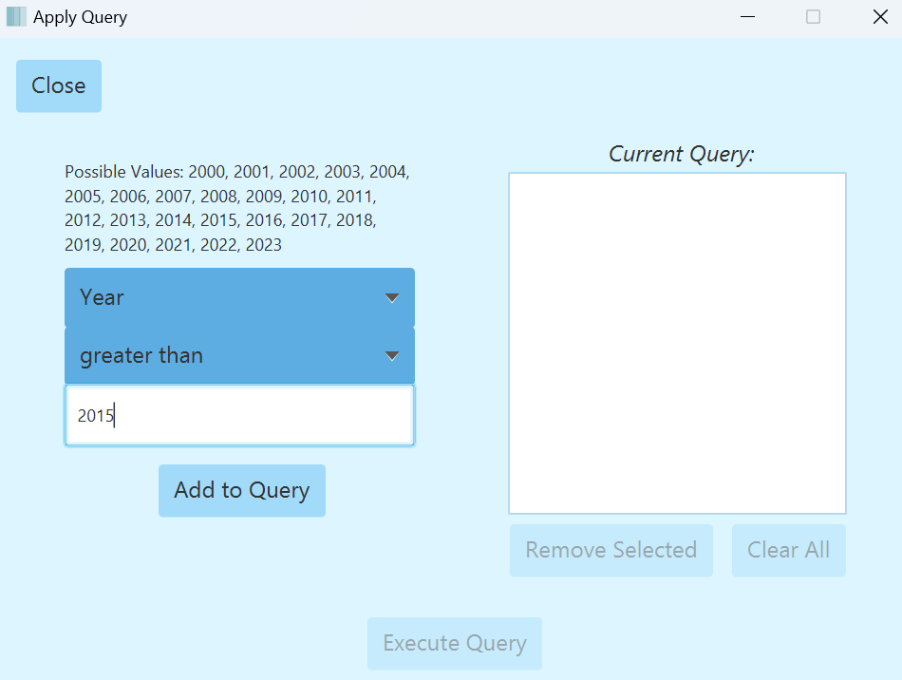Say you would like to look at all crashes which happened since 2015.

Select the attribute Year

Choose the operator greater than.

Enter 2015 into the statement field.

The exact example is shown by **figure 10**.

You would then select add to query.

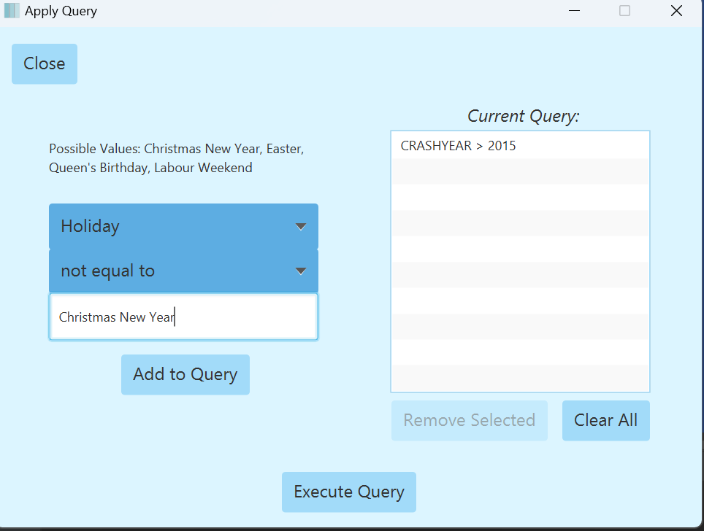Building on the previous example. With this you might only want to see crashes that occurred but not during the Christmas New Year period.

Figure 11: The second example query. Built on the current query

Select the attribute Holiday

Choose the operator not equal to.

Enter Christmas New Year into the statement field.

The exact example is shown by **figure 11**.

# Filter Columns

The "Filter Column" feature in the CQS application allows users to display specific columns or attributes of their choice. This guide will walk you through the process of using this feature to customize your data viewer.

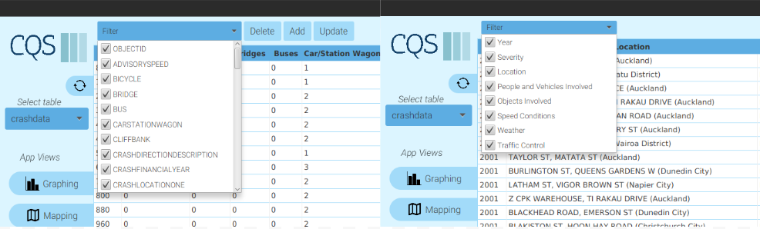

Figure 12: Raw data filter (left) Simple CAS filter (right)

## Activating column filters

Access the Filter Menus as show in **figure 12**.

Locate and click on the Filter dropdown button. This can be found at the top of your screen, as shown in the image provided.

Once clicked, a dropdown menu will appear, presenting you with a list of all available columns. Each column has a checkbox next to its name.

To hide a column, simply uncheck the box next to the column's name.

If you want to show a column, ensure its box is checked.

After making your selections, the data viewer will automatically update to show only the columns you've chosen.

### Common errors

#### a. In the event that you uncheck all boxes and no columns are selected:

The data viewer will display no columns. This is an expected behavior, so don't be alarmed.

# Map View

The "View Map" feature in the CQS application provides users with a visual representation of crash locations from a selected dataset. This guide will assist you in efficiently navigating and utilizing this feature.

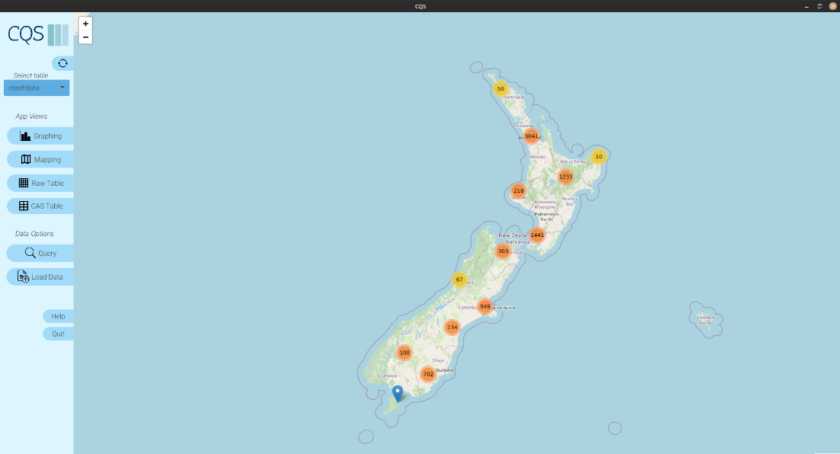

Figure 13: Zoomed out view of the Map

The crashes are clustered whilst zoomed out as shown in **figure 13**. Click on the clusters, scroll, or select the + button in the top left corner to zoom in.

## Detailed Pin Information

To view detailed information about crashes located on the map, click on a single blue pin. This feature will not show the details of a cluster. Meaning you must be zoomed in sufficiently to be able to click a single crash pin.

An example of the detailed pin description is shown by **figure 14**. To get out of the detailed pin view simple click anywhere else on the map view.

Figure 14: The Detailed Pin Information View.

# Graph View

The "Generate Graph" feature in the CQS application. This guide will provide you with step-by-step instructions on how to effectively utilize the "Generate Graph" feature to visualize your data.

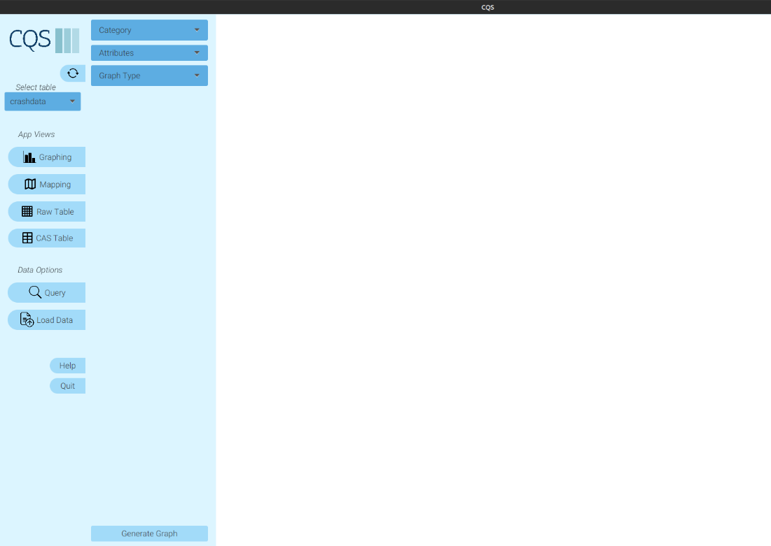

Figure 15: Graphing view

## Generating a Graph

From the "Category" dropdown show in **figure 15**, choose the data category you wish to visualize.

Modify Attributes (Optional):

Based on your chosen data category, the "Attributes" dropdown will populate with relevant options. If you want to omit specific attributes, simply unselect them.

Choose Graph Type:

From the "Graph Type" dropdown, select how you would like your data to be represented (e.g., bar chart, pie chart, line graph).

Generate Your Graph:

Once you're satisfied with your selections, click on the "Generate Graph" button.

The graph will then be generated based on your chosen parameters and displayed to you.

### Updating an Existing Graph with different dataset

If you've previously generated a graph and wish to update it:

Begin by selecting a different table from the "Select table" dropdown.

Note: Your current graph will remain unchanged at this stage.

After making your selections, click on the "Generate Graph" button again.

The current graph will update to reflect the newly selected data.

### Common errors

#### a. No Category Selected:

If you click "Generate Graph" without choosing a category, a warning will appear: "Please select a category."

Action: Select a category and try again.

#### b. No Attributes Selected:

If all attributes are unselected and you attempt to generate a graph, you'll see: "Please select at least one attribute."

Action: Ensure at least one attribute is selected and proceed.

#### c. No Graph Type Chosen:

Should you select a category but neglect to choose a graph type, the system will alert you with: "Please select a graph type."

Action: Choose a desired graph type from the dropdown and retry.

# Pagination

The "Pagination" feature within the CAS data viewer. This guide will assist you in navigating multiple pages of data, ensuring you efficiently access the desired information.

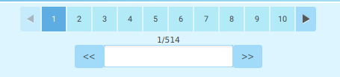

Figure 16: Pagination tool bar

## Navigating Pages

### Using singe arrows

Navigate through pages by simply clicking on the arrow buttons displayed in **figure 16**.

Single Right Arrow: Proceed to the next page.

Single Left Arrow: Return to the previous page.

### Using page numbers

Directly clicking on a page number will navigate to that specific page.

### Direct Page Entry

Type a specific page number into the text field located between the navigation arrows.

The data viewer will refresh, showing the data from the specified page.

### Using Double Arrows:

Double Left Arrow: Navigates to the very first page.

Double Right Arrow: Navigates to the very last page.

### Common errors

a. Non-Numeric Entries:

If a non-numeric value (like a text string) is entered into the text field:

The table view remains unchanged.

b. Out-of-Range Numbers:

If a page number exceeding the available pages is input:

The table view redirects to the very last page.

# Delete Table

The "Delete Table" feature allows users to efficiently remove tables from the system. This ensures streamlined database management and facilitates easy decluttering.

Figure 17: Context menu showing delete table option

## Deleting a table

Ensure that the application is open.

Locate the Table Dropdown Box below the ‘Select table’ header

Look for the dropdown box displaying the table names. This is usually located at the top of the interface, as indicated in the provided image.

Right-click on the dropdown box to reveal a context menu as in **figure 17**.

Select "Delete" Option from the context menu.

A confirmation prompt will appear, asking you if you are sure about deleting the table. Confirm the deletion by selecting "Yes."

### Additional information

Note: Once a table is deleted, the action is irreversible. Ensure that you have backed up important data before deleting.

Restricted Tables: Some tables, like the ‘crashdata’ table, might be crucial to the system and cannot be deleted. If you attempt to delete such tables, a prompt will inform you that this action is not allowed.